<http://www.youtube.com/watch?v=8r_IErxmoUc> (Yout Tube Link)

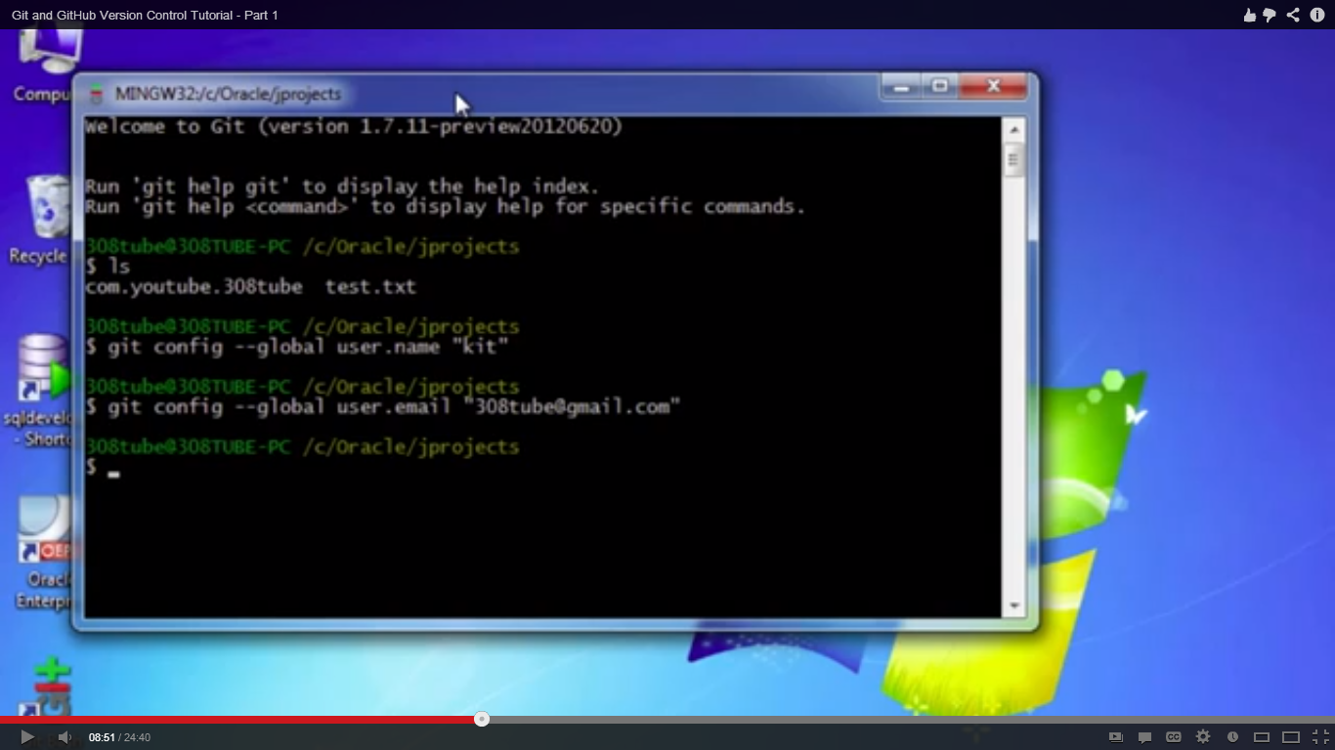

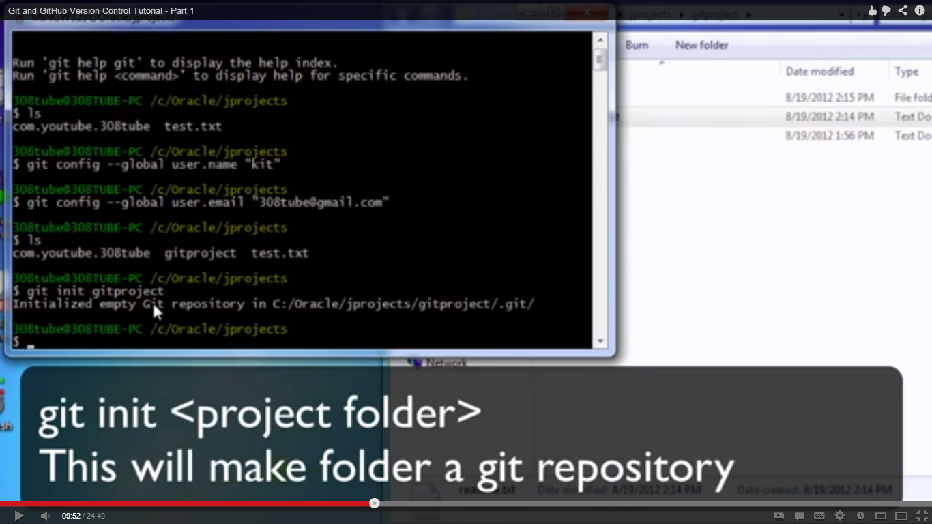

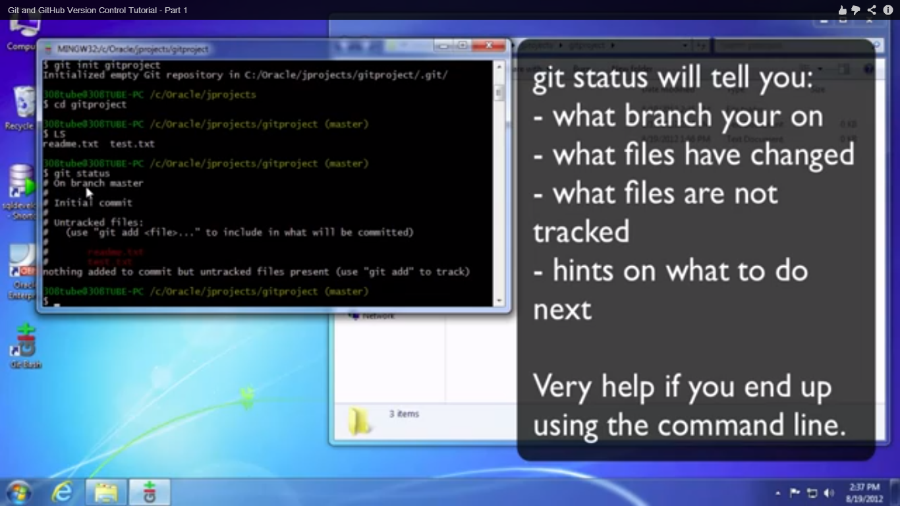

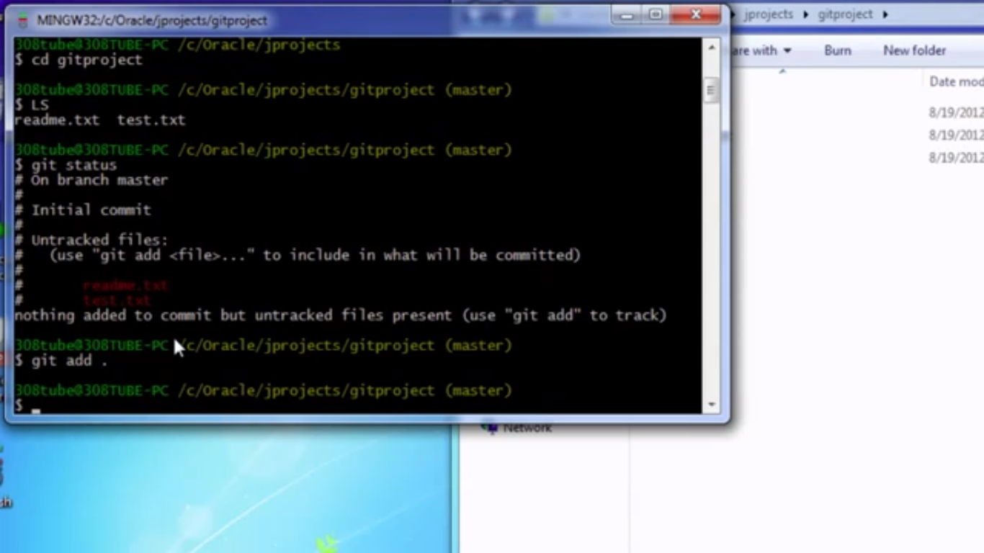

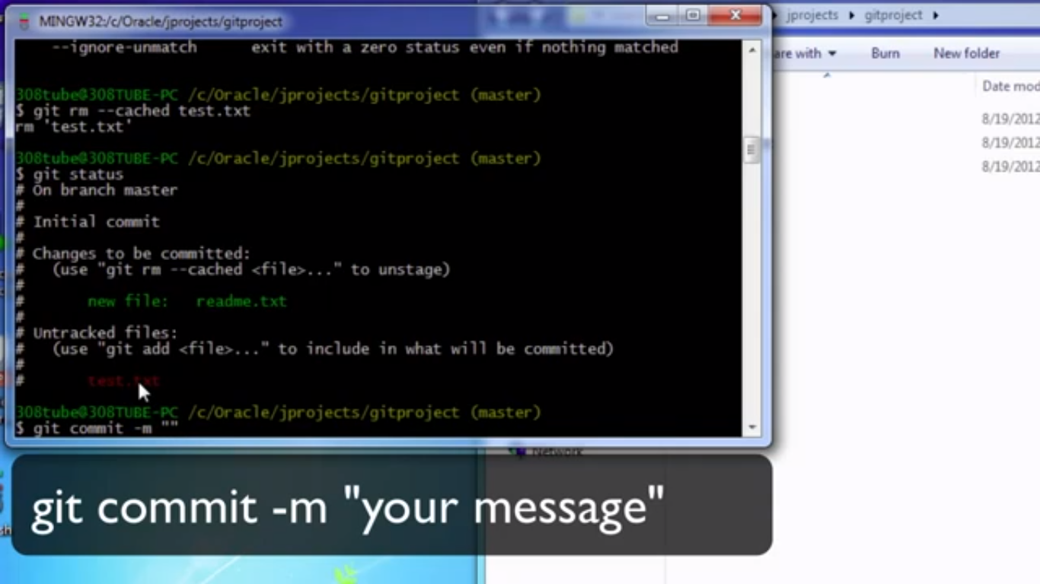

Git log : gives the log

Git status : status of repository

Everytime you change a file in git . First add that file to the repository and then do a commit. Direct commit would fail

Git diff : Before the file is committed to staging area, gits tells the difference

Git diff –cached : After the file is committed to staging , if you want to know the difference.

`git log –online – log with just message which you gave while commiting

Git commit –a –m “” : git commit with –a commits all the files to the staging area

Git status –s : shows the file which are modified with just name and not the verbose details

Git init project

**GIT HUB**

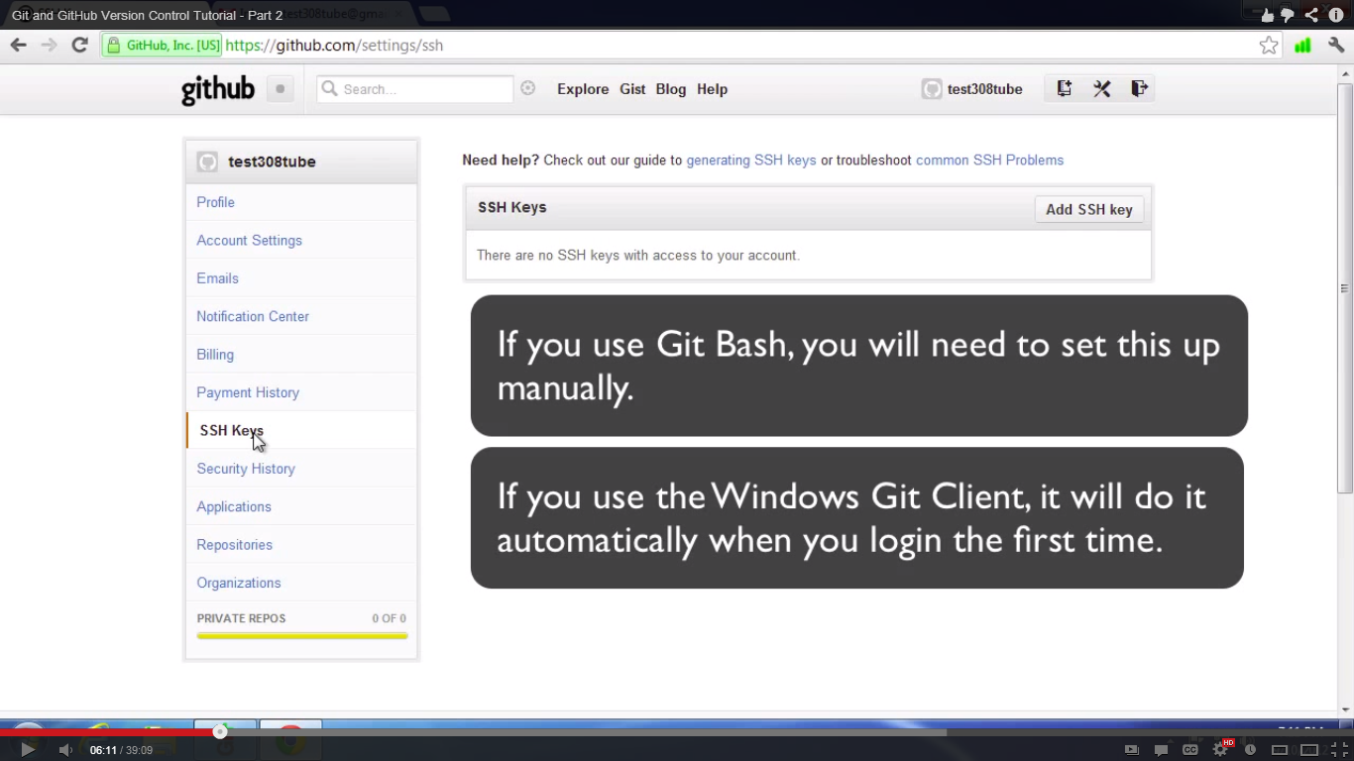

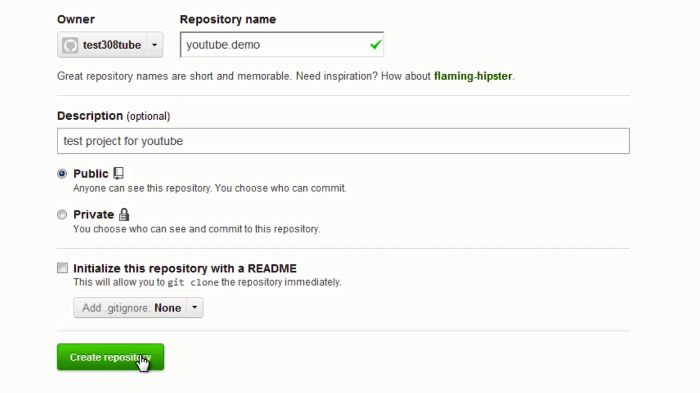

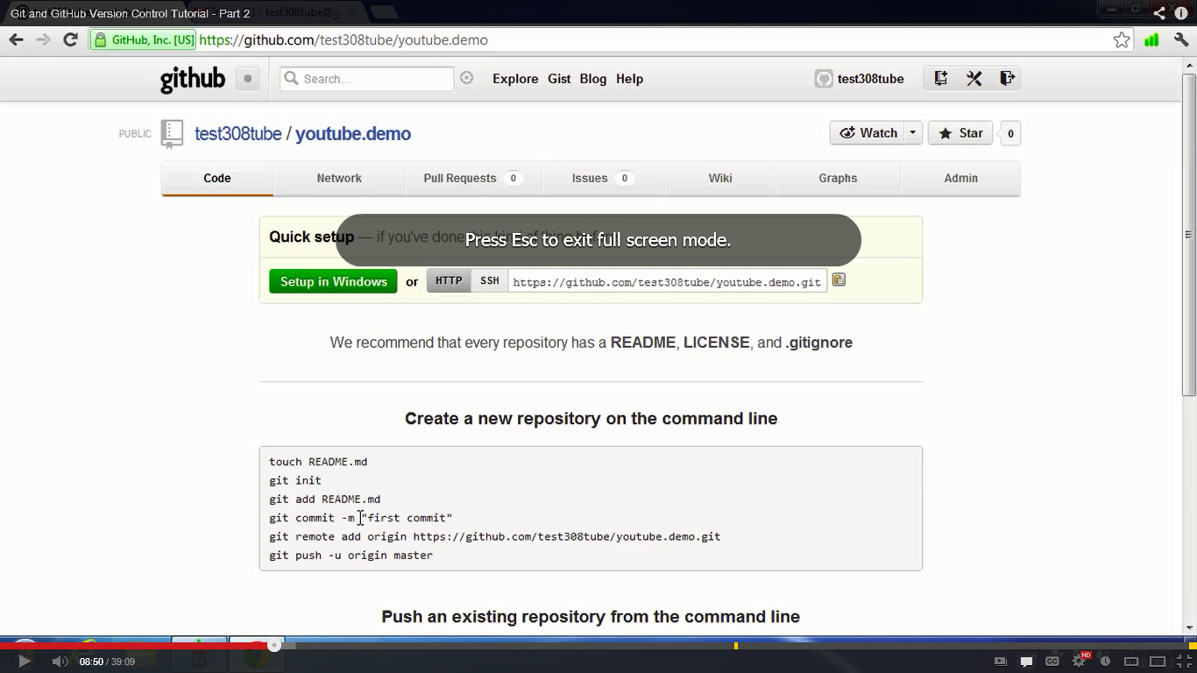

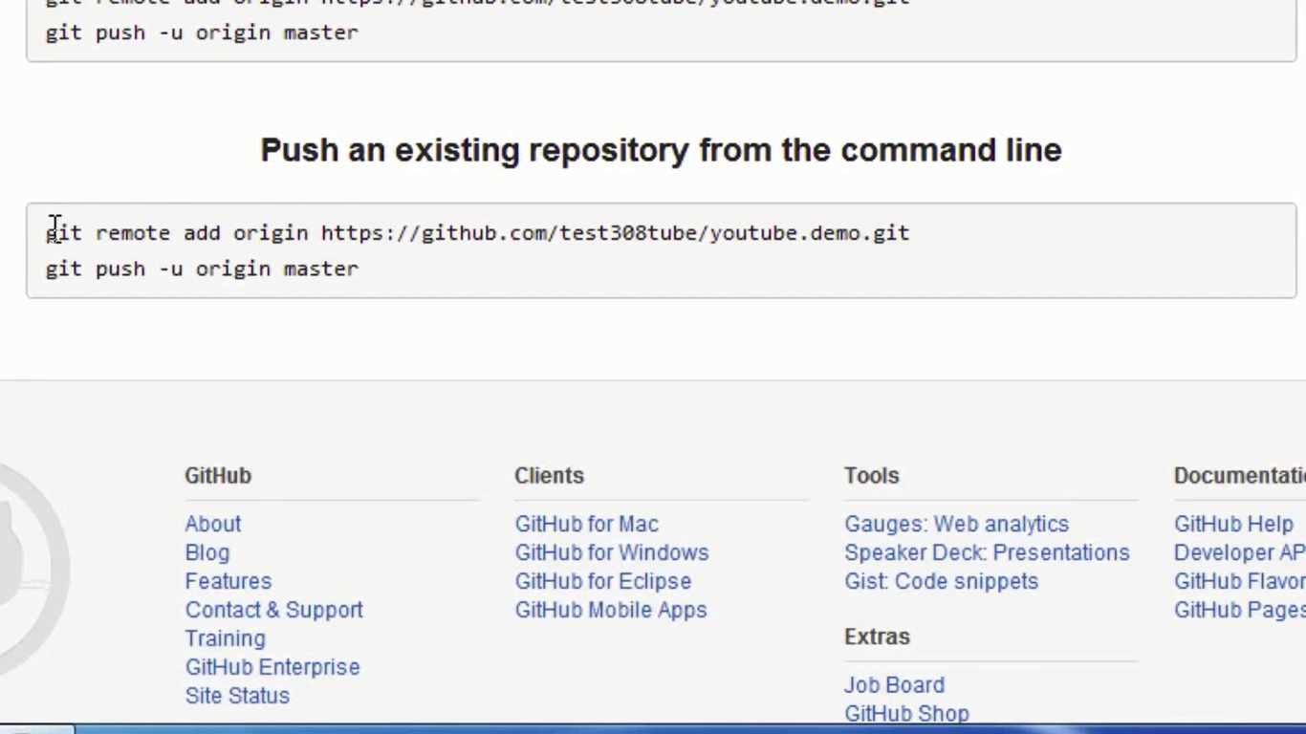

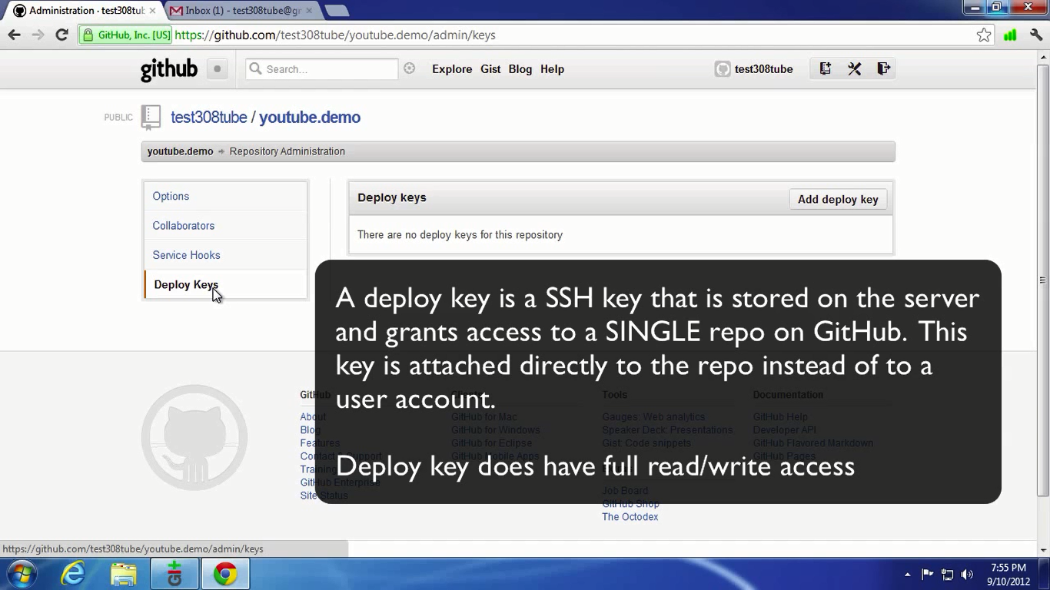

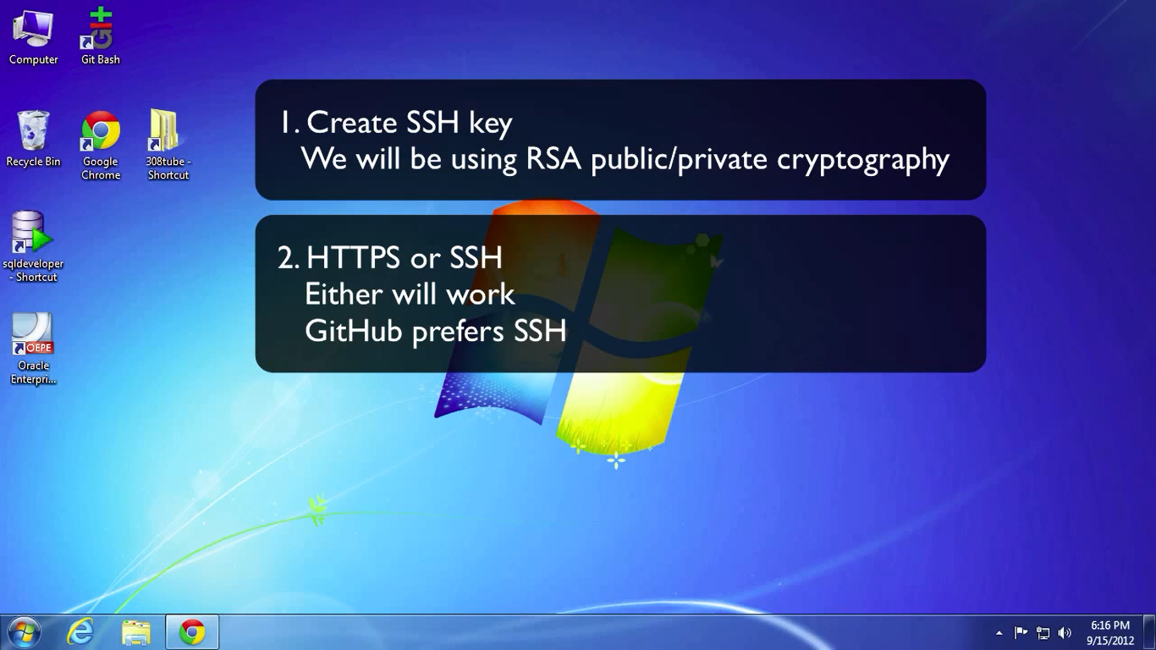

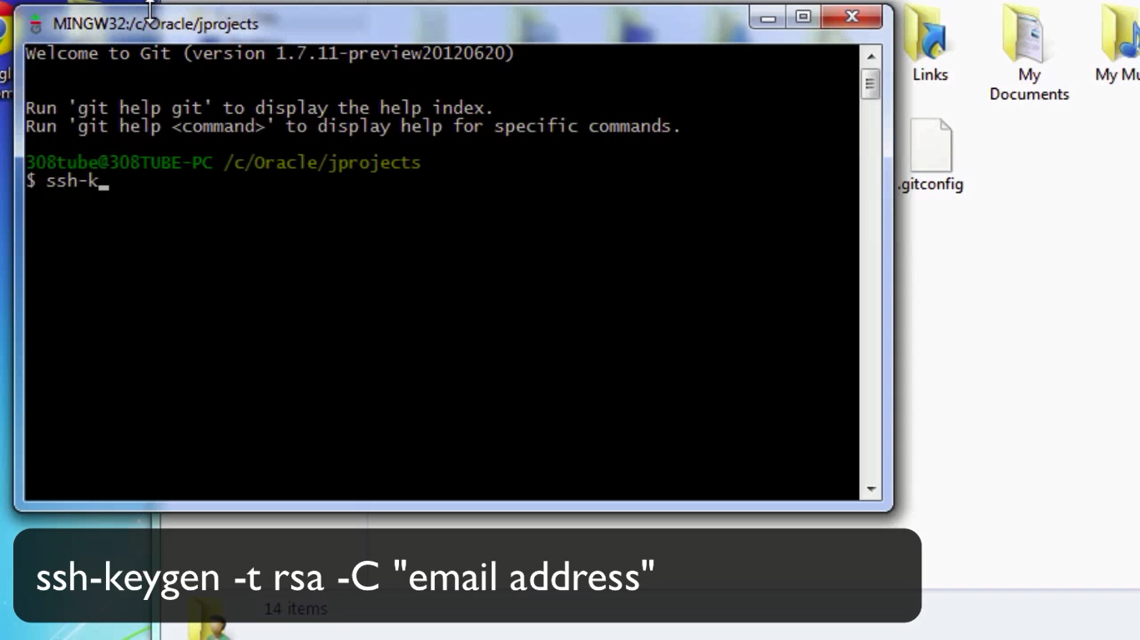

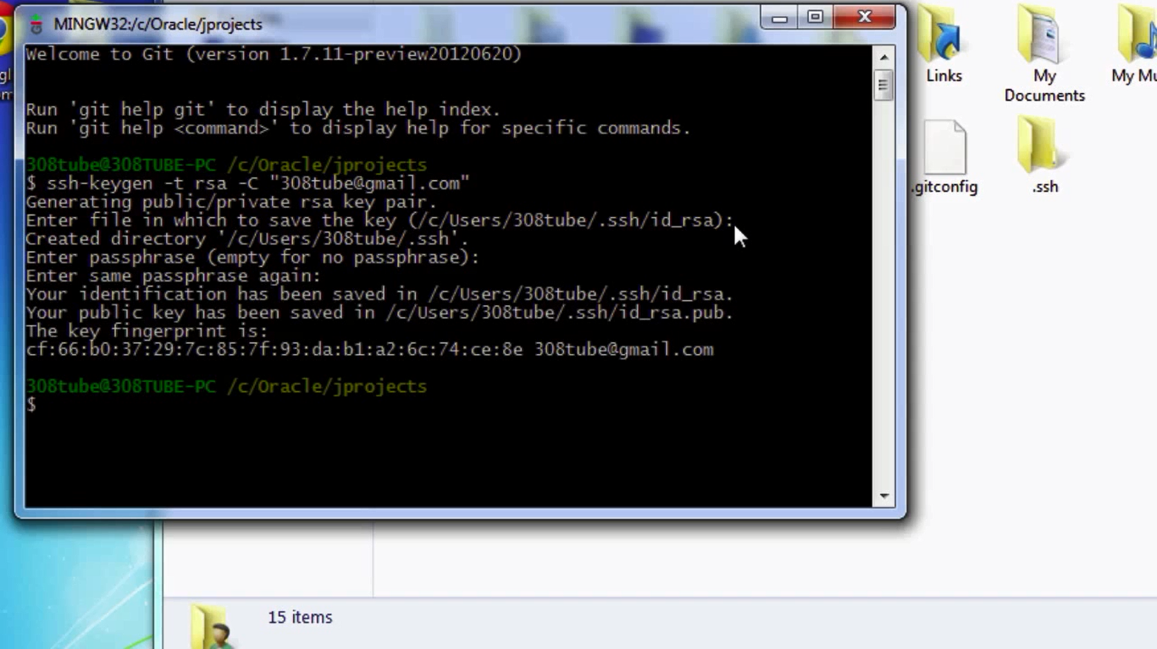

**Take the public key from .ssh folder of your profile and then goto -- >**

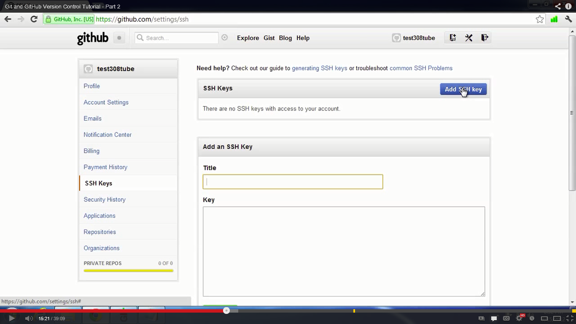

**Add the ssh key and now to test if correctly set, do**

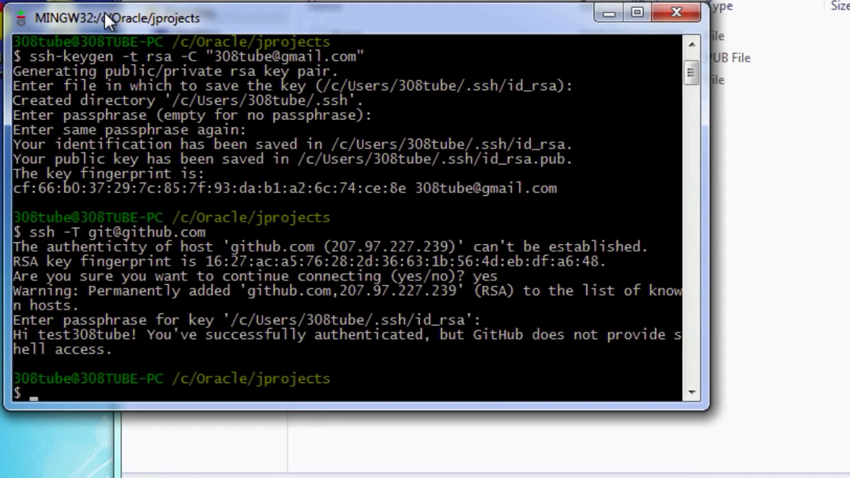

**To add a local project to git hub first goto git hub , select SSH tab and do below**

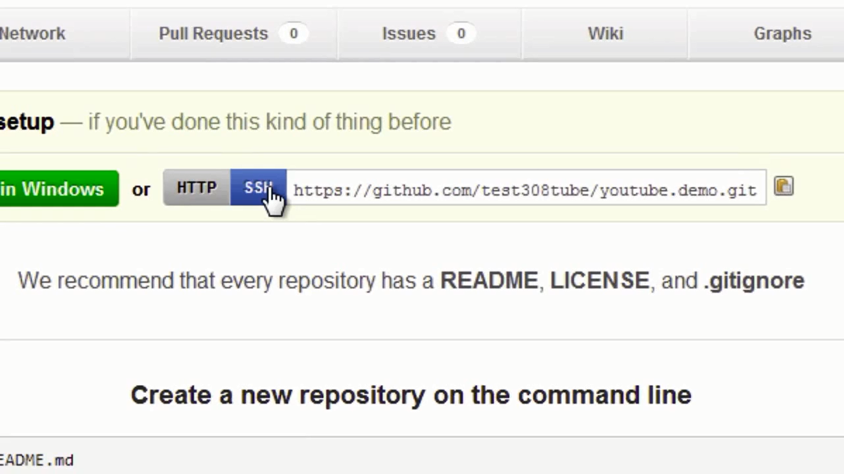

**Take the location and do the below thing**

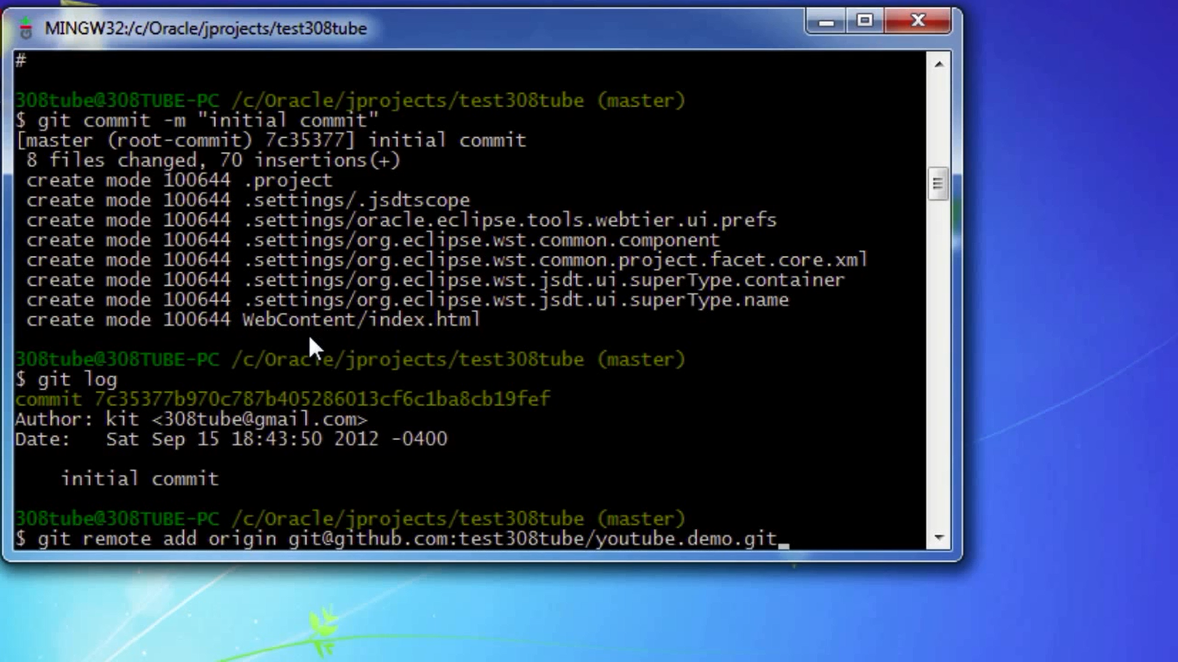

**Now add the files like below**

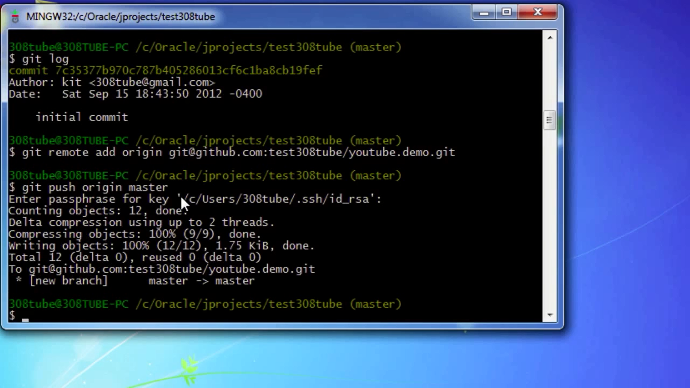

**If you do any changes to a file locally. First add the file to the staging area , then commit to the local repository and then push it to master repository**

